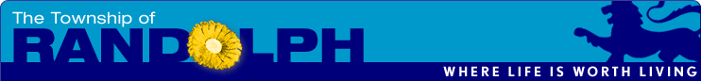
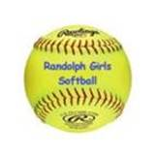
http://www.randolphgirlssoftball.org

The Randolph Girls Softball Program is preparing for our 2022 Season and is greatly appreciative of your charitable donation to help us continue funding our long standing successful program that fosters:

* A fun, safe and positive environment for girls from our community to enjoy the game

* Learning fundamentals (throwing, fielding, hitting, base-running and pitching)

* Teamwork

Each year, approximately 200 Randolph girls participate in the softball program. Our program is run by volunteers and largely supported by donations from individuals and local businesses. In the past few years, we have had a very successful program.

While we have new energy with an increase in new players and volunteers, the ongoing costs to provide a successful program for the girls continues to present challenges. Your financial support would go a long way to ensure Randolph has a vibrant softball program for our girls, provide you with a return on your investment and continue to demonstrate your ongoing support of our community, “Where Life is Worth Living”.

Please consider being a sponsor of this wonderful program. Our sponsorship offering includes signage at Brundage Park softball complex on Carrell Road posted from April through October. Not only will you be providing support of our athletic program, your generosity will be appreciated by many local families, as well as also offering an opportunity to increase patronage of your business through the expansion of your advertising plan for a nominal investment of only $250.

If you are willing to sponsor, please reply so that a member of the Randolph Girls Softball Committee can contact you, complete your sponsorship form and collect your generous donation.

Thank you for your support!

The 2022 Randolph Girls Softball Committee

___________________________________
Randolph Girls Softball Organization is part of Randolph Township and thus a nonprofit tax-exempt organization. Your contribution is tax-deductible to the extent allowed by law. No goods or services were provided in exchange for your generous financial donation. EIN: 226-002239

